**How to use S.T.A.R technique in the job interview**

Competency(能力) questions make up a large part of most job interviews and from a company’s point of view they allow an objective assessment of a candidate’s experience, and the qualities that make them suitable for the job.

It’s known as the STAR technique and by using questions that require these types of answers it is easier for the employer to compare all the people who are applying for the job in a methodical and structured way.

By using this step-by-step method, you will be able to answer each question in a systematic manner, without forgetting the important stuff. Here we take a look at every stage of the STAR interview method. The answer to these questions will usually be between a minute and three minutes long.

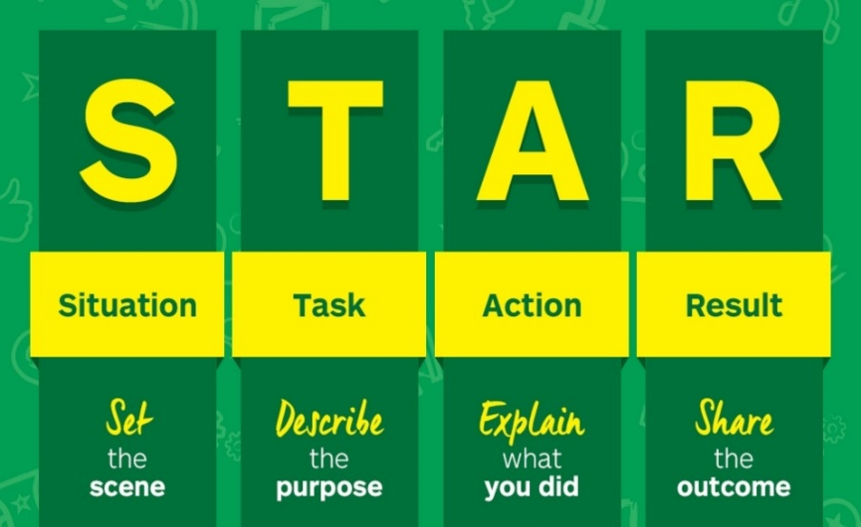

**Situation**

This is about setting the scene, giving a context and background to the situation. So if you’re asked a question about time management, your reply would need to include the details of the project you were working on, who you were working with, when it happened and where you were.

**Task**

This is more specific to your exact role in the situation. You need to make sure that the interviewer knows what you were tasked with, rather than the rest of the team.

***Action***

This is ***the most important*** part of the STAR technique, because it allows you to highlight what your response was. Remember, you need to talk about what you specifically did, so using ‘I’ rather than team actions – otherwise you won’t be showing off the necessary skills the employer is looking for.

Be sure to share a lot of detail, the interviewer will not be familiar with your history, although remember to avoid any acronyms and institutional language.

What you’re trying to get across here is how you assessed and decided what was the appropriate response to the situation, and how you got the other team members involved – which in turn is a great way to demonstrate your communication skills.

For example, if you are asked about dealing with a difficult personality on your team you would talk about how you decided to take a certain course of action to avoid making the situation worse or upsetting the individual.

**Result**

The result should be a positive one, and ideally one that can be quantified. Examples include repeat business, an increase in sales by 15% or saving the team 5 hours a week. The interviewer will also want to know what you learnt from that situation, and if there was anything you’d do differently the next time you were faced with that situation.

The STAR technique enables you to showcase your relevant experience with the interviewer in a methodical manner. We recommend doing some in-depth preparation before the interview so that you can have some great examples to quote.